|  |  |  |
| --- | --- | --- |
|  | **Ideation Phase** | |
|  | **Brainstorm & Idea Prioritization Template** | |
|  |  |  |
| Date |  | 19 September 2022 |
| Team ID |  | PNT2022TMID23529 |
| Project Name |  | Smartfarmer – IOT enabled Smart farming |
|  |  | Applications |
| Maximum Marks |  | 4 Marks |
| Name |  | LAKSHMINARAYANAN.VR |

**Brainstorm & Idea Prioritization Template:**

Brainstorming provides a free and open environment that encourages everyone within a team to participate in the creative thinking process that leads to problem solving. Prioritizing volume over value, out-of-the-box ideas are welcome and built upon, and all participants are encouraged to collaborate, helping each other develop a rich amount of creative solutions.

**Step-1: Team Gathering, Collaboration and Select the Problem Statement**

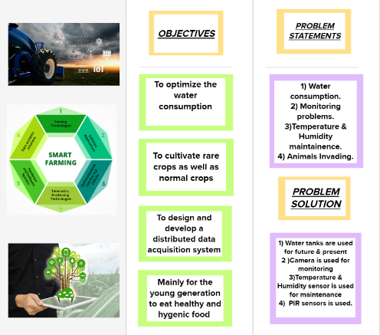



**Step-2: Brainstorm, Idea Listing and Grouping**

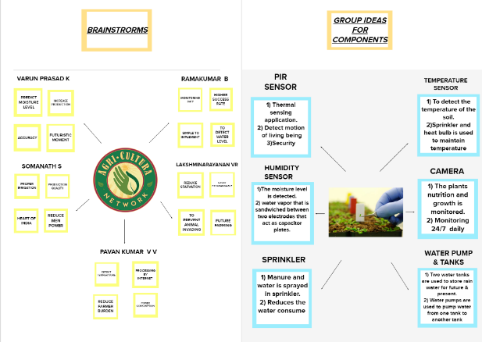

**Step-3: Idea Prioritization**

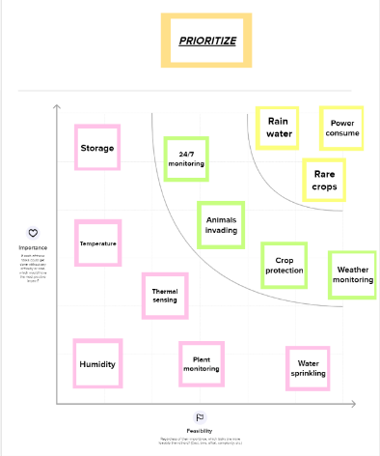

**Overall Block Diagram:**

